

**System Design Document.**

**for**

**Counselling Appointment System**

**Prepared by Group 5 Members**

**Team Project**

**Computer Science**

**Supervisor Mr Benjamin Odiyo**

**4 August 2018**

**Version 1.0**

Table of Contents

Table of Contents 2

1 . INTRODUCTION. 3

1.1 Purpose and Scope 3

1.2.3 Future Contingencies 5

1.4 Points of Contact 6

1.5 Glossary 6

2 . SYSTEM ARCHITECTURE. 8

2.1 System Hardware Architecture 10

2.2 System Software Architecture 10

2.3 Internal Communications Architecture 10

3 . FILE AND DATABASE DESIGN 11

3.1 Database Management System Files 13

3.2 Non-Database Management System Files 13

4. HUMAN-MACHINE INTERFACE. 14

a) Panel Layout 14

b) Color scheme 14

c) Information presentation 14

4.1 Inputs 14

4.2 Outputs 15

5 DETAILED DESIGN 17

5.1 Hardware Detailed Design 17

5.2 Software Detailed Design 17

# 1 . INTRODUCTION.

## 1.1 Purpose and Scope

This document describes the design for the dean of students online counselling appointment booking system. This system will be developed to replace the existing manual system. It will provide effective counseling appointment scheduling for Egerton University students. This system was designed considering the following goals:

**Scalability**

The system must be scalable in terms that it can support many users communicating

**Usability**

Since the end-user will be using the system while performing work, it is essential for the system to be intuitive and easy to use.

**Multiple Users**

The system should support tasks that are performed by multiple users in concert, supplying each with the necessary information and statuses at the appropriate time.eg the student must be in a position to tell the available counselors and counselors must be in a position to set their availability and know pending appointment requests.

**Scope of the System**

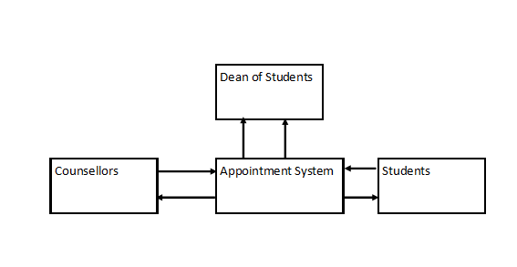

Fig.1.1 Booking appointment System Scope

**1.2.1 System Overview**

Online counselling appointment system is an on line students counseling appointment system to be used by undergraduate students in Egerton University. The availability of counselors determines the capability of students to book an appointment and proceed on and meet a counselor of their choice. This will allow counselors to plan their work early since there will be a system facilitating prior scheduling.

This system will provide a platform for preparation and communication between students and their counselors as far as setting an appointment is concerned. Counselors will be receiving alerts via email as soon as the students book an appointment.

The dean of students can add a counsellor, remove, approve their permission to be away and print reports on counselling appointments and schedules. The dean will also know from his/her desk of the available counselors and those planning to be away.

This application will maintain the entire data in a centralized and secured database server to maintain consistency in report generation and allows the dean’s office members of staff access from any location since it is an online application that allows multi user access of system. Various roles and authentications have been provided and access to various areas in the system will restrict users according to the roles given to them. The aim of this application is to reduce the manual effort needed to manage the schedules of appointments and response to the need of each and every student by the counselling office members of staff.

.

**1.2.2 Design Constraints.**

**Business Constraints**

1. Time.
2. Budget
3. Resource

**Other Constraints, Assumptions and dependencies**

* The Organization to use this system should have Internet connection and Internet server capabilities.
* The users have sufficient computer literacy skills.
* The users know the English language, as the user interface will be provided in English
* Members of staff at the Deans office will provide their information as captured by the organizations Human Capital Department.
* The coding should be error free.
* The system should be user-friendly so that it is easy to use for the users
* The information of all members of staff in the Dean of Students office must be stored in a database that is accessible by web browsers
* The information of all students must be stored in a database that is accessible by web browsers
* The system should have more storage capacity and provide fast access to the database
* The system should provide search facility and support quick transactions
* The appointment scheduling system will be running 24 hours a day.
* Users may access from any computer that has Internet browsing capabilities and an Internet connection
* Users must have their correct usernames and passwords to enter into their online accounts and do actions
* The specific hardware and software due to which the product will be run
* On the basis of listing requirements and specification the project will be developed and run
* The end users (admin) should have proper understanding of the product
* The system should have the general report stored
* Any update regarding the employee is to be recorded to the database and the data entered should be correct.

### 1.2.3 Future Contingencies

The system will allow future modifications and amendments. In future, if there are any changes to the system that will be necessary they can be done easily without changing the overall design.

**1.3 Document Organization**

The entire document is in Times New Roman Font. The headings are numbered 1,2,3... and so on and sub-headings are numbered x.1, x.2.... and so on. Both headings and sub-headings are in bold*.*

Main title: Font Times New Roman size 14

Sub titles: Times New Roman and size 12

Content: Times New Roman and size 12

## 1.4 Points of Contact

**Project Name :** Online Counseling Appointment System

**Project Team :** Group 5 Code Blooded C/O Egerton University Computer Science

## 1.5 Glossary

|  |  |
| --- | --- |
| **Aggregation** | One or more classes that make up another class. |
|  |  |
| **Attribute** | A piece of data or knowledge that an object has. |
| **Broadcast** | The action of transmitting data through all available channels. Used to find local servers. |
| **Class** | A definition of an object, which contains a description of the data within the object and the operations it performs. |
| **Communication Module** | The module that allows communication between the client and the server. |
|  |  |
| **Developers** | The team responsible for the development of the software system. |
|  |  |

* PHP -> Hypertext Preprocessor
* SQL -> Structured query Language
* SRS -> Software Requirement Specification
* Administrator: A login id representing a user with user administration privileges to the software
* User: A general login id assigned to most users
* Client: Intended users for the software
* SQL: Structured Query Language; used to retrieve information from a database
* SQL Server: A server used to store data in an organized format
* User Interface Layer: The section of the assignment referring to what the user interacts with directly
* Application Logic Layer: The section of the assignment referring to the Web Server. This is where all computations are completed
* Data Storage Layer: The section of the assignment referring to where all data is recorded
* Use Case: A broad level diagram of the project showing a basic overview
* Class diagram: It is a type of static structure diagram that describes the structure of a system by showing the system’s cases, their attributes, and the relationships between the classes
* Interface: Something used to communicate across different mediums
* Unique Key: Used to differentiate entries in a database

# 2 . SYSTEM ARCHITECTURE.

The system will be made up of three main components:

* Database for storing different types of data such as employee’s details, logins etc managed by an SQL database server.
* Appraisal System engine (main core of this system implemented in PHP).
* User Interface Engine (by means of this server user interact with database through the web browsers).



**Database**

**SQL server**

**Appointment System**

**User Interface Engine (PHP)**

**Dean of Students Office/Counsellors**

**Web browser**

**Students on Personal Computers**

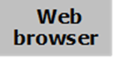

Fig.2.1 System Architecture

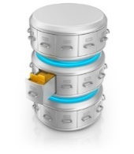

**Web Browser**

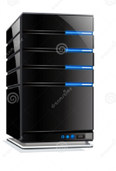



## 2.1 System Hardware Architecture

The proposed platform is a Web application written mainly in Object Oriented PHP with MySQL database. This is to ensure that the system is robust system that is scalable and can be improved to handle more users as it grows. The technical requirements are:

* PHP framework
* Apache Web Server
* The system will use a MySQL database.

This software package is developed using PHP ,Java Script HTMLCSS and Bootstrap for front end .

* The Database is MYSQL Server as the back end to store the database.
* Operating System: the system should work on all OS platform (Windows, Linux or MAC)

## 2.2 System Software Architecture

The system shall interface with an Oracle or Mysql database. To implement the project we used Object Oriented PHP/HTML language for its more interactive and easy to understand and support*.*

***Server Side***

*Apache Webserver will accept all requests from the client and forward specific requests to server hosting this system. A development database will be hosted locally (using MySQL); the production database is hosted centrally (using Oracle).*

***Client Side***

*An OS capable of running a modern web browser which supports HTML version 5 ..*

## Internal Communications Architecture

* + SMTP will be used to facilitate communication via email
  + The HTTP protocol will be used to facilitate communications between the client and server.
  + The Port number used will be 80.
  + This System can be accessed through Google Chrome and Mozilla Firefox web browsers.

# 3 . FILE AND DATABASE DESIGN

The database will consist of 5 functional tables.

1. **Admin table**

This table will store all the personal details for the dean of students. This will include,user name and password of the dean of students.

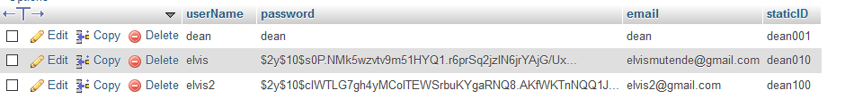

Fig.3.1 Admin Table

1. **Counselor’s table**

This table will store all the counsellor’s details in the Dean of students office. This will include, counsellors name, phone number their email and password.

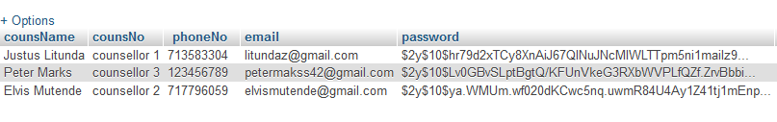

Fig.3.2 Counselors table

1. **Schedules table**

This table will be used to store all the data about schedules set by counsellors. The fields will include away time, date, period, Next time available, next data available, reason for being away, approval,counsellors number and counsellors name.



Fig.3.3 Schedules table

1. **Session table**

This table consists of the session set by the student. The details are students registration number, student registration number, counsellors booked(counselors number) ,session date, session start time and session end time

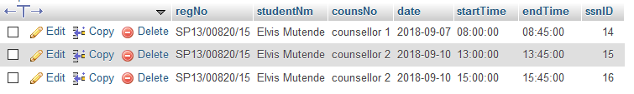

Fig.3.4 Session table

1. **Student table**

This table will contain students details such as userid,user email,user password, student registration number ,students name and phone number.



Fig.3.5 Student Login table

## 3.1 Database Management System Files

1. Text files (names and passwords)
2. SQL statements to

**.** DBMS SCHEMAS

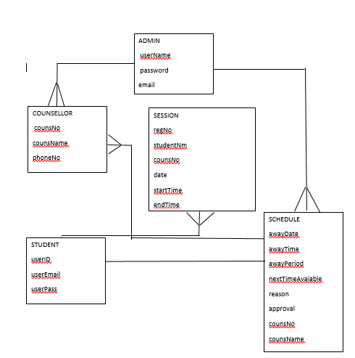

## 3.2 Non-Database Management System Files

* CSV database files used as inputs
* PHP files – will be used for displaying the output and formatting
* Documents (PDFs, spreadsheet and word docs) – For displaying reports
* IMAGES (.jpg, .png)
* Mail files

# 4. HUMAN-MACHINE INTERFACE.

## HOMEPAGE LAYOUT

The homepage layout will be designed to provide the user with hyperlinks to other pages.

It will lead to the following pages;

a) Students

b) Counsellors

c) Dean

d)About Us

e) Contact Us

## Color scheme

The key to effective use of color is simplicity. This system will avoid the use of screaming colors or luminous. The system will stick with the following colours

* Blue
* Green
* Brown.

## Information presentation

The system will avoid cluttering a page with irrelevant data. Forcing an operator to search for the required information increases response time and potential errors. The system shall have a consistent set of menu buttons and functions from screen to screen.

## 4.1 Inputs

All data will be entered manually to the system by use of a keyboard and mouse on a computer through data entry screens and forms.

The inputs consist of the query to the database. In this project, the inputs will be the queries as fired by the users like create an account, change password and set schedule.

1. **Student Login Form**

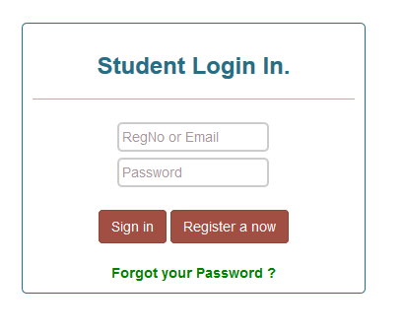

Fig.4.1 Student Login form

Fig.4.2 Student registration form

1. **Student Registration Form**

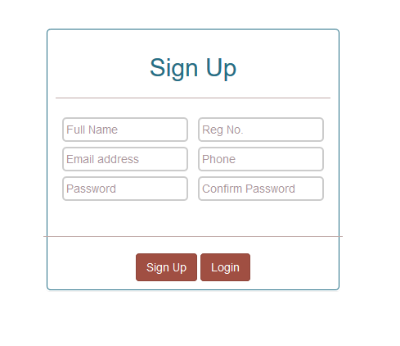

## Outputs

The output consists of reports generated by the Dean of students on the schedules set.

Other outputs also include;

* Booked appointments
* Available counsellors

**GUI**

The system provides good graphical interface for the students and the administrator who is the dean of students to operate on while performing their tasks such as create user, set schedule ,and reset password.

* The user interface is responsive.
* All the modules provided with this system must fit into this graphical user interface and accomplish to the standard defined
* The design is simple and all the different interfaces are in cool colours and display a good contrast.
* The user interface should be able to interact with the user and allow the user to perform their duties and play their roles as expected.
* No student can log in as a counsellor since the counsellors will be under the dean of students directly.

# 5 DETAILED DESIGN

This section provides the information needed for a system development team to actually build and integrate the hardware components, code and integrate the software modules, and interconnect the hardware and software segments into a functional product.

## 5.1 Hardware Detailed Design

Hardware Requirements.

* Computers (client) and a server to host the system
* Network.
* A well maintained printer (In case of hard copies)
* 2GB and above of RAM
* 2.0 GHz of processor or higher.
* 100 MB of hard disk space.

## 5.2 Software Detailed Design

The system will consist of several different functionalities

1. Dean of students Authentication & Authorization function
2. Dean can view sessions of students who have booked for counselling.
3. Counsellors authentication and authorization module.
4. Students sign up and login module
5. Student can search for booked Session
6. Dean of students Authentication & Authorization function

This consists of the Dean of Students login.

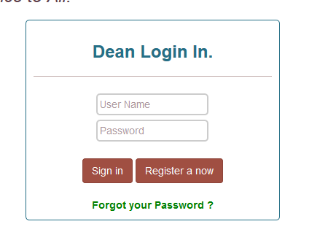

Fig.5.1 Login Interface

1. **Dean can view sessions of students who have booked:**

Before a student books for appointment.

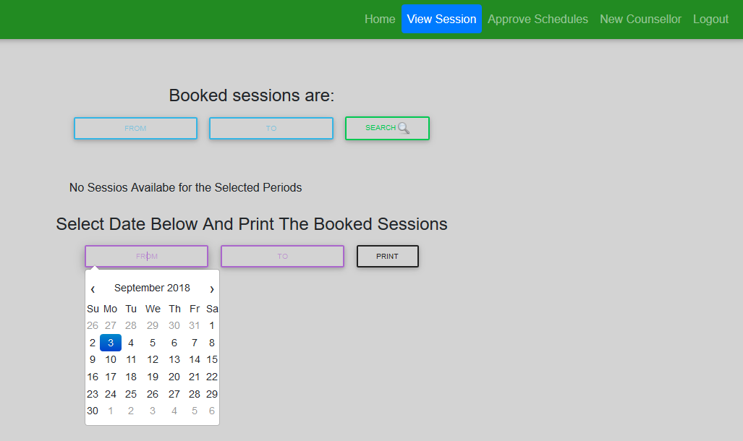

Fig.5.2a View sessions Interface

After a student has booked a session

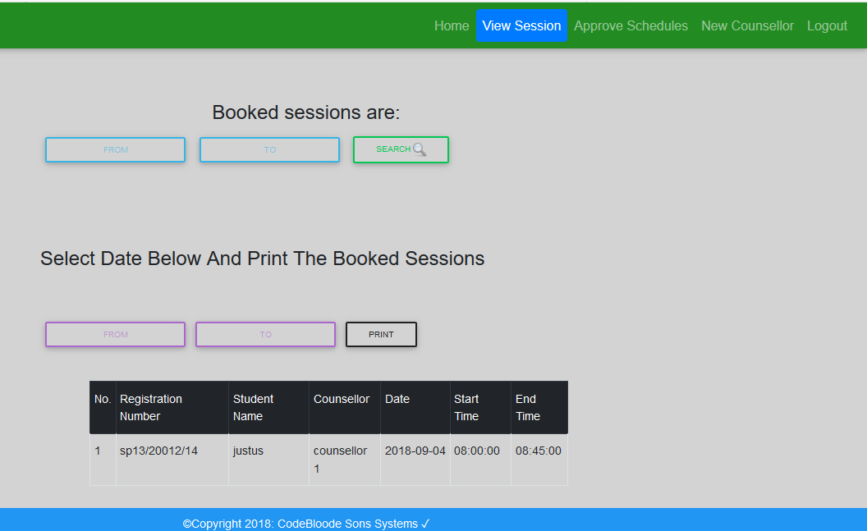

Fig.5.2b Booked appointment Interface

3.**Student can log in/Sign up**



Fig.5.3 Student sign up form

**4.Student can book Appointment :**

The student can book an appointment with the dean.

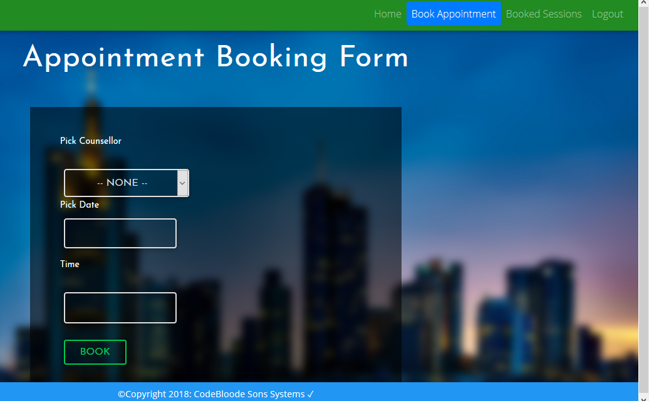

Fig.5.4 Student Booking appointment interface

5.**Student Search Booked Session**

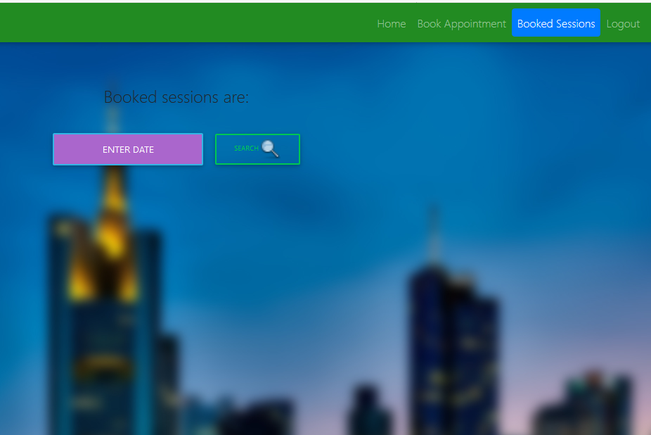

Fig.5.5 Student searching for a booked appointment interface

# 6.0 Use case Realization

This section contains diagrams showing the modelling of the use case. This use case shows the process of the counsellor setting a schedule,the student chekingand selecting the available time and then booking an appointment,the dean making a follow up ,the dean can view appointment and print logs

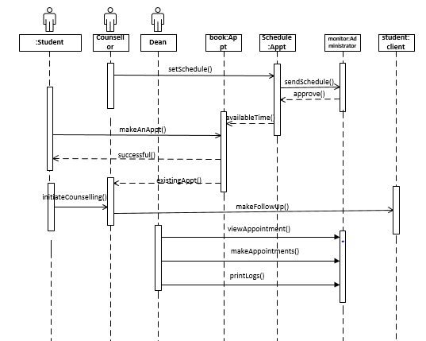

Fig.6.0 Sequence diagram for manager’s activities

Fig.6.0.Use case Diagram

# 7.0. SYSTEM INTEGRITY CONTROLS

The system will be protected against security threats. Security to the system will be provided with login and password. Even the passwords will be encrypted in the database to provide utmost security using the DBMS_CRYPTO package.

* User can reset forgotten password through email authentication.
* A counsellor will not have the rights to add another counsellor .
* Only the dean of students will have the rights to view a counsellors leave or absence request.
* Information input restrictions.

*Only registered user will use information system.*

* Information input accuracy, completeness, and validity

*Information put on the system will be checked for accuracy, completeness, and validity. (moderate)*

* Error handling

*Error messages will be provided by the system.*